**American International University-Bangladesh**

Advanced Programming with Java [A]

Project Description

**Project Title: Travel management system (ghura ghuri)**

**Group No/Name: /GCORE**

|  |  |  |
| --- | --- | --- |
| **Student Id** | **Student Name** | **Signature** |
| 19-40903-2 | Refat, Mahfujar Rahman | Refat |
| 19-40861-2 | Mustakim, S M Tusher | *Tusher* |
|  |  |  |

**Short Description of your project:**

|  |
| --- |
| Nowadays people are more and more interested in traveling. So we chose this idea from the thought of making travel easier for travelers through this application. This application will have 3 users. Admin, employees, and customers. Admin will be able to access and update everything in this application. Employees will have limited access. They will be able to see various information about customers and act accordingly. However, if there is a complex problem, they will need admin approval. And customers will be able to open their own profiles and book the place where they love to go. And they can change their profile. Through this application, the user can safely go to their desired place without any hassle. Customers can easily get transportation, hotel accommodation, and catering facilities through this application. Users can also Shop for any accessories for traveling. And also users can book hotels, buy transport tickets, etc. So We will try to make this application more user-friendly. |

**E-R Diagram:** (Please use any online tool to draw E-R diagram then upload as image here)

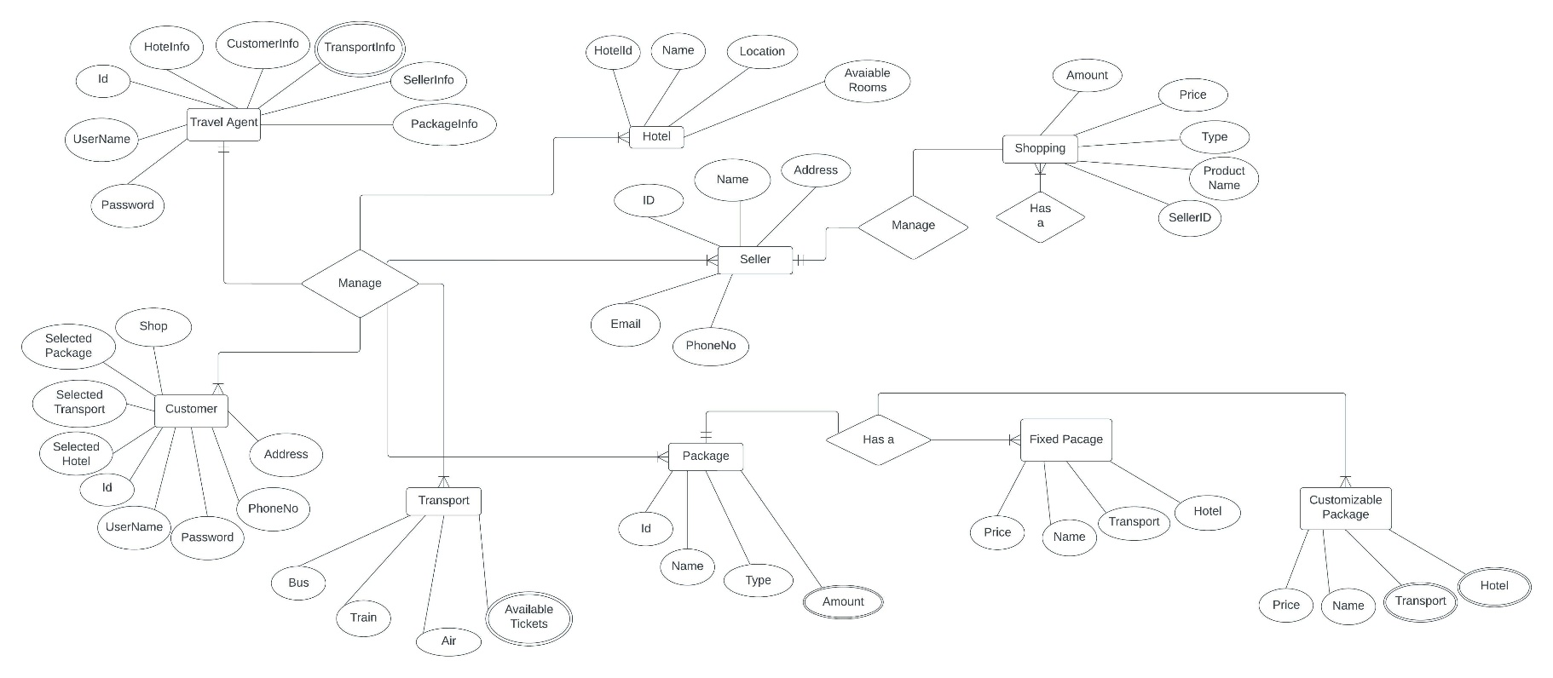

**Roles & Responsibilities:** (Please provide all user types in your system and name/mention the attributes/features of your roles)

User 1: (Admin)

Describe the Features:

Admin will be able to access and update everything in this application. There have some features which the admin can use.

1. Admin can add the employee (an employee registration).

2. Admin can delete the employee.

3. Admin can see all the user booking request.

4. Admin can change user booking information.

5. Without admin approval employee can not change user booking information.

6. Admin can delete user profile with a valid reason.

User 2: (Employee)

Describe the Features

Employees will be able to access and update everything in this application without admin information and some important issues There have some features which the employees can use.

1. Employees can log in

2. Employees can edit their profiles.

3. Employee can see all the user booking request.

4. Employees can change user booking information with admin approval.

5. Employees can request the admin to delete their user id with some valid reason

User 3: (Customer)

Describe the Features

1. without login customers can see some information about our website, They also can see some features like shopping, hotel, gallery, tickets, etc all the similar information but they can not get the services.

2. they can log in and sign up.

3. They can shop similar things to travel.

4. they can book a hotel of their own choice.

5. They can buy bus tickets, train tickets, plane tickets, etc what they want.

6. They can book fixed packages for traveling.

7. They can customize the package for traveling.

8. They can see all their own booking information.

9. They can select a guide if they need it.

9. They can change their own profile.

10. They can easily pay with bkash, nagad, upay, or any visa card, mastercard, and so on